# Iteration 3

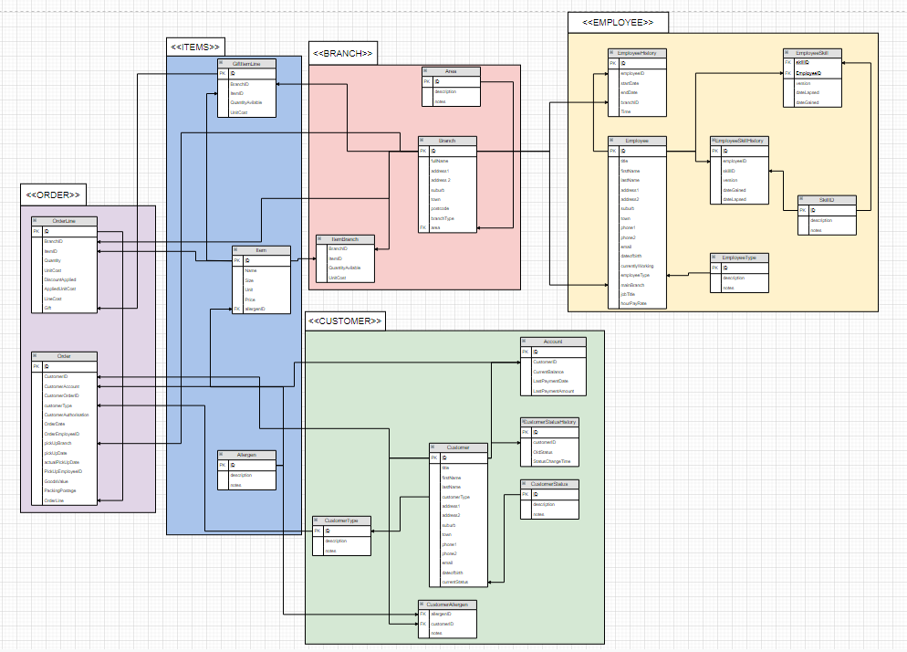

Iteration 3:

Taking iteration Two and turning it into an ERD diagram which is more of a Dataflow diagram. No Attributes or Multiplicity just theory crafting the Dataflow. Tables have been "packaged" into groupings so I know what they are for.

Time has been added to EmployeeHistory incase of instances where a Employee has worked at 2 branches within one day, stores how long they worked there.